

**Submitted by:**

Manahil Shahzad

**Referred to:**

Sir. Muhammad Affan

**Roll no:**

466695

Fundamentals of Programming

Lab Manual 8

Task 1

int main () {

int average,summage=0;

int ave[5];

cout<<"Enter 5 values of array: "<<endl;

for (int i=0; i<5; i++) {

cin>>ave[i];

summage+=ave[i];

}

average=summage/5;

cout<<"The average is: "<<average<<endl;

return 0;

}

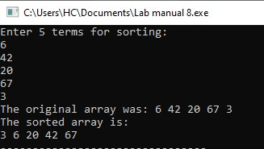

Task 2

int main() {

int Sort[5];

cout <<"Enter five terms for sorting: " <<endl;

for (int i=0;i<5;i++)

cin>>Sort[i];

cout<<"The original array was: ";

for (int j=0;j<5;j++)

cout<<Sort[j]<< " ";

for (int i=0;i<5-1;i++) {

for (int j=0;j<5-i-1;j++ ) {

if (Sort[j]>Sort[j+1]) {

int Temp=Sort[j];

Sort[j]=Sort[j+1];

Sort[j+1]=Temp;

}

}

}

cout<<"\nThe sorted array is: "<<endl;

for (int i=0;i<5;i++) {

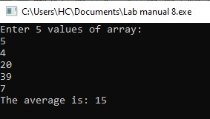 cout<<Sort[i]<< " ";

}

return 0;

}

Task 3

void selection_sort(int arr[], int n) {

for (int i = 0; i < n - 1; i++) {

int min_idx = i;

for (int j = i + 1; j < n; j++) {

if (arr[j] < arr[min_idx]) {

min_idx = j;

}

}

swap(arr[i], arr[min_idx]);

}

}

int main() {

int arr[] = {64, 25, 12, 22, 11};

int n = sizeof(arr) / sizeof(arr[0]);

selection_sort(arr, n);

cout << "Sorted array is: ";

for (int i = 0; i < n; i++) {

cout << arr[i] << " ";

}

return 0;

}

